Tn5 nuclease test 141021. Exp. conditions:

Tn5 - transposase without cognate oligos - 31 uM
Tn5+1030/31 with bound MEDS oligos - 12.5 uM
Reaction volume 100 uL, 250 ng HMW DNA (20 Kb), TAPS-MgCl buffer with 8% PEG8000.

Counterdilution of Tn5 w/wo bound oligos:
1. Tn5 - 0 uL, Tn5+1030/31 - 5 uL
2. Tn5 - 0.5 uL, Tn5+1030/31 - 2.5 uL
3. Tn5 - 1 uL, Tn5+1030/31 - 1.25 uL
4. Tn5 - 2 uL, Tn5+1030/31 - 0.625 uL
5. Tn5 - 3uL, Tn5+1030/31 - 0 uL
Duplicate sets incubated at 55C - 7 min, 37C - 15 min.

Assay by Agarose gel, 1% minigel @ 75 V

Gel 1. Stop by adding 1/5 vol 0.2% SDS, 55 C 7 min. 10 uL on gel.

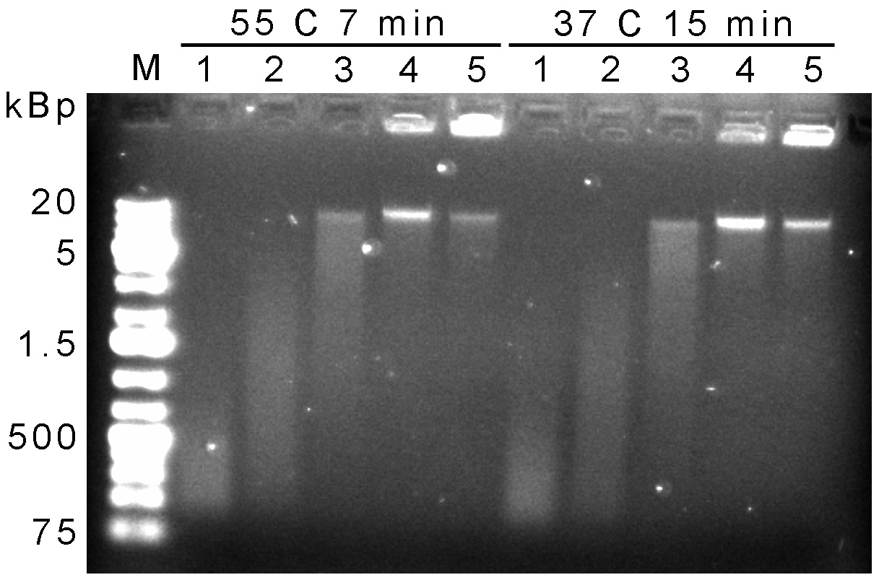

Gel 2. Additionally + 1 uL of 20 mg/mL Proteinase K, 55 C 15 min

