Purification of Tn5 from pTXB1-Tn5ES clones (v31). 2021-01-20.

Rickard Sandberg, Gösta Winberg, Karolinska Institutet, Stockholm, Sweden.
(Rickard.Sandberg@ki.se)

Tn5 data:
(Tn5 = 53300 MW. Eμ = 86525. (A280: 8.65 = 5.33 mg/ml = 100 uM, A280: 1.000 = 0.616 mg/ml = 11.56 uM)

Tn5ES is wt Tn5 except for the E54K and L372P. Inh start (M56) does not matter in T7 expression system. Tn5 sequence from Patents is less stable and less active (additional mutations: M56A, K200R and S303G).

Notes on expression testing:
The basic techniques for protein expression in pTXB1 fusion constructs is described in the NEB Impact Kit Instruction Manual. Genotypes of the expression strains are as follows: (C3013: lysY/LacIq, Cam^{R}, lacZ:T7 gene1, (lon), OmpT, etc. ; ER2566: No LacIq, but lacZ:T7 gene1, (lon), OmpT, etc ) (pTXB1 carries a copy of LacIq.). Colonies of 3013 (or ER2566) may vary in Tn5 expression. Expression should be tested as follows before growing up 1L cultures.

Grow a fresh colony in 5 mL LB O/N. Take off 1 mL culture and put the remaining 4 mL on ice. Dilute 1 mL sample to 2 mL with LB medium. Split in two. Grow at 37C for 1 h. Add IPTG to 0.25 mM in one of the tubes and shake for 4 h at 23-25 C. Pellet cells and resuspend pellet in 50 uL water. Add 50 uL 2x SDS sample buffer and heat both samples at 95 C for 3-5 min. Check that they are not viscous. Pellet the samples at 14K for 3-5 min. Run 5-10 uL supernate (dep. on slot size) on a 4-12% NuPAGE gel. Stain as usual with CBB R250.

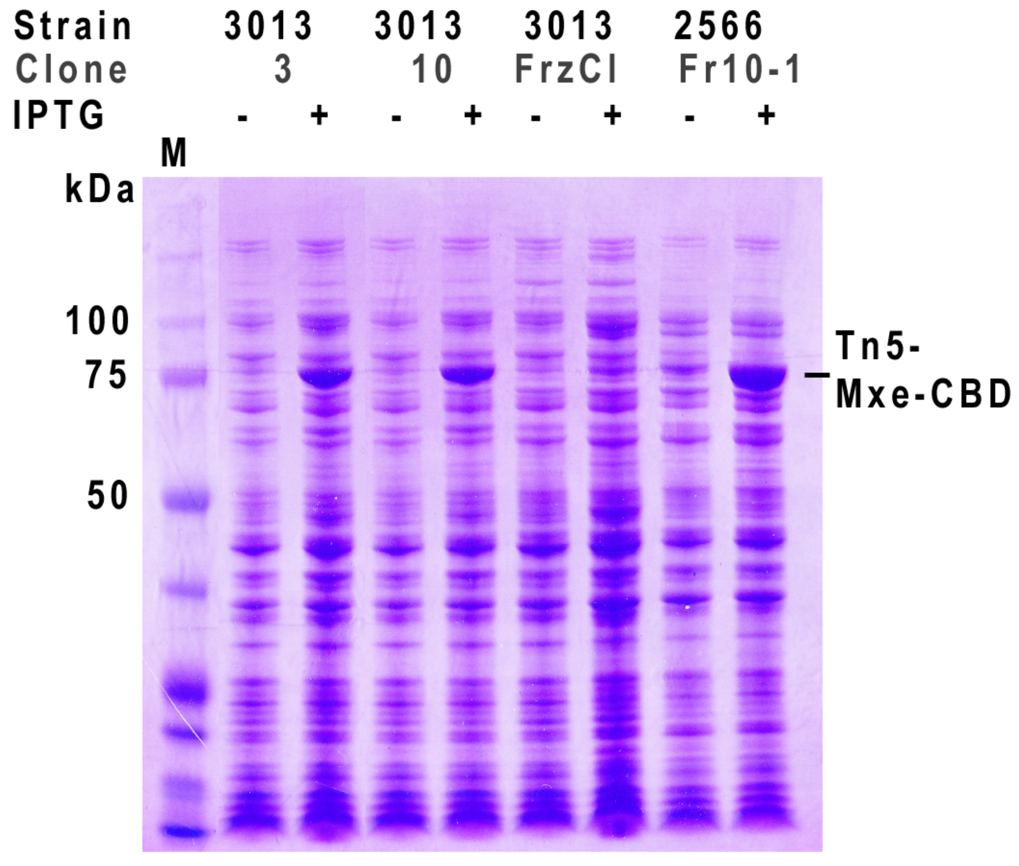
Fig. Expressing and non-expressing clones of Tn5 in 3013 and 2566 cells. Fr = was frozen in freezing media for bacteria.

When growing up a large scale culture, it may also be useful to check expression and growth rate. Growth rate is an indicator of how efficiently Tn5 expression is suppressed before induction. If doubling time before IPTG induction is 25-30 min, the Tn5 induction is well suppressed. If doubling time is 45 min or higher, there is inefficient suppression of the fusion protein expression (by LacIq) and the final yield of fusion protein after IPTG induction will be low. When culture has reached 0.75-1.0 OD600, withdraw 1 mL of the culture for SDS gel as above. When IPTG induction is finished, take another 1 mL sample for SDS gel analysis. Since the cell pellets are frozen before continuing the prep, these samples can be checked on a SDS gel for overexpression of the ≈80kDa Tn5-Mxe-CBD fusion protein. Despite the fact that beta-ME is added to the sample buffer, cleavage of the fusion protein is not seen on the gels. Presumably because of the slow cleavage process and the denaturation of the protein structure by SDS.

Growth and induction:
Transform pTXB1-Tn5ES into C3013 or ER2566 on Amp. Pick clones and grow up directly in 5 mL LB Amp. Freezing single clones of transformed C3013 or ER2566 (at -70 in freezing media) for later use is not recommended. Both these cells are RecA positive and the plasmid may not be stable in these cells.

1L cultures are inoculated with 4 mL O/N culture after testing, as described above. LB should be pH 7.2-7.3, since high density growth generates more acid metabolites which limit cell growth. Grow @37C for 3 - 4h, to A600 0.75 - 1.0. Reserve 1 mL for SDS analysis. Add 1 M IPTG to 0.25 mM and chill cultures in cold (ice) water to about 10C. Grow @ 23C for additional 4 h. A600 = 2. 0- 3.0. Reserve 1 mL for SDS gel analysis (see below). Yield ≈ 2.7 - 3.8 g cells. Freeze pellet @ -70C O/N, thaw next morning, resuspend in 60 mL HEGX @ 0-4C and sonicate. Frozen pellets keep for several years at -70-80 C.

HEGX: 20mM Hepes-KOH, pH 7.5, 0.8M NaCl, 1 mM EDTA, 10% Glycerol, 0.2% TX100, Complete. (Mxe-Tn5 has pI=8.4, Tn5 has pI 9.4).

2x HEGX (1.6 M NaCl) stock solution: 200 mL 99.5% Glycerol (252 g), 320 mL 5M NaCl, 40 mL 1M Hepes, pH 7,5, 4 mL 500 mM EDTA, 4 mL Triton X-100 (use a 5 mL hypodermic syringe).

Comment: The volumes and other conditions in the purification protocol should be scaled to the yield of induced cells. A 10 mL column is sufficient for up to 5 g of cell pellet, 2.5 - 3 g for a 5 mL column etc.

Sonicate: Use 10 - 12 cycles of about 40-45 bursts at 80% duty cycle, output 7 on Branson with 1/2 inch tip. Temp should not go over 10C. Cool in salt-ice between each cycle until sample T is about -1 - -5C. For fast cooling, use stainless steel beakers. Immediately pellet JA17 15K rpm, 30 min, 4C. Discard pellet which may contain about 20% of the protein in inclusion bodies.

Sonication conditions may vary with the sonicator brand. With a Sonics Vibracell, run 20-24 pulses (1 min 10sec total time) at 2 sec on, 1 sec off, Amplitude 70% with ½ inch tip. Temperature should not exceed 10 C and cooling should be to -2 C as above.

PEI precipitation: With cleared 60 mL lysate on Mag stirrer, add dropwise 2.2 mL 10% PEI (Sigma P3143). Collect precipitate at 15K, 10 min, +4C in JA17.

(P3143 PEI is basic. Neutralize to pH 7.5: weigh 2.7 g 50% PEI ( = 2.5 mL at 1.08 g/mL) into a 50 mL screw-cap tube, Add 5 ml H2O, 1.5-1.75 ml 37% HCl. Mix well. Add 2 mL 5 M NaCl, 0.25 mL 1 M Hepes, pH 7.5, 7.5 uL 0.5 M EDTA, 0.25 mL 10% Triton X-100. Vt adjust with H2O to 12.5 mL. Final: 10% PEI. Check pH and adjust if needed.)

Binding of Tn5-Mxe-CBD fusion protein to Chitin in solution and packing into column.
Pipet 6 ml of 50% chitin suspension into each of two 50 mL Falcon tubes. Add 1x HEGX buffer to 50 mL, Mix and centrifuge at low speed (1000 rpm) to sediment the chitin. Aspirate the supernate and resusupend chitin again in 50 mL 1xHEGX buffer. Sediment and remove as much as possible of the supernate.
Add half of the cleared lysate to each of the tubes with Chitin gel. Rotate the tubes over end at 7 rpm overnight at 4C.

Following binding to the Chitin, sediment the gel (1000 rpm), discard supernate and resuspend gently in 50 mL of 1xHEGX. Repeat once. Resuspend gel in 20 mL HEGX, pool and pack into column. Wash with 10 vols of 1xHEGX (20mM Hepes-KOH, pH 7.5, 0.8M NaCl, 1 mM EDTA, 10% Glycerol, 0.2% TX100, Complete). Drain to top level of column. Add oligo solution as described below.

Additional chaotropic wash
Protocol may be used for other Chitin fusion proteins. For RTX (91.5 kDa), used 10-20 col vol 1xHEGX, Then 4 col vol 2 M urea in 1x HEGX, 4 col vol 1x HEGX before elution with 50 mM DTT in 1x HEGX.

The binding capacity of the Chitin column is reported to be 2 mg MBP-Mxe-CBD/mL = 28 nmoles/mL acc. to NEB data, thus the maximum capacity of a 10 mL chitin column is about 280 nmoles of fusion protein.

A. On column assembly of Tn5 with MEDS oligos:
Tn5 can be assembled with the two MEDS oligos either separately and subsequently mixed, or, as described in this on-column assembly protocol, with both MEDS oligos mixed before binding to the Tn5 protein. MEDS oligo-nucleotides are bound by Tn5 protein while C-terminally attached to the Chitin matrix through its Mxe-CBD fusion partner. This significantly facilitates the large-scale production of active transposase. In addition, the on-column assembly of transposase eliminates excess unbound MEDS oligonucleotides, which may interfere with sequence library construction, particularly from single cells.

For a 5 mL Chitin column with bound Tn5, add 400 nmoles of the mixed and annealed Tn5MEDS + A/-B oligonucleotides (see procedure below) to the column in 8 mL degassed HEGX buffer. Leave the column at 4 C for 48h. Wash with 20 vol HEGX to remove free MEDS. Cleave Tn5-MEDS from the Chitin column in 50 mM DTT and dialyze vs at least 3 changes of 500 mL 2x Tn5 dialysis buffer (see below) in 50kDa dialysis tubing. Leave at least for 12 h for each dialysis. Measure A280 and calculate Tn5 concentration. For final use, adjust to 12,5 μM concentration in 50% Glycerol and 1X Tn5 dialysis buffer.

Note: DTT dialyzes very slowly out of the dialysis bag. If dialysis is not complete, the A280 readings of Tn5 concentration will be too high because DTT has an absorbtion maximum which coincides with protein (280 nm). Residual DTT (over 2 mM) will make the A260/A280 ratio lower than the actual value, which confounds the calculation of oligo binding to Tn5.

Oligo calculations and reannealing to DS MEDS oligos:
Make 1 mM solutions of all oligonucleotides in 10 mM Tris, pH 8, 10 mM NaCl, 1 mM EDTA and keep at -70C.

Preparing MEDS solution to add to the Tn5 on the Chitin column.
For a 5 mL Chitin column, in a 15 mL screw-cap tube mix:
200 uL 1 mM pMENTS1030, (34-mer) (or 1 mM ME-Rev, 19-mer)
200 uL 1 mM FC-121-1030, (34-mer)
1.6 mL 10 mM Tris, pH 8, 10 mM NaCl, 1 mM EDTA
= 2 mL (total 200 nmoles of the DS oligo after reannealing)

Similarly, mix
200 uL 1 mM pMENTS1031, (33-mer) (or 1 mM ME-Rev, 19-mer)
200 uL 1 mM FC-121-1031, (33-mer)
1.6 mL 10 mM Tris, pH 8, 10 mM NaCl, 1 mM EDTA
= 2 mL (total 200 nmoles of the DS oligo after reannealing)

Place each 15 mL tube in a beaker with 75-80 C water*. Leave on benchtop to cool and reanneal (1-2 hours). The oligos form a fully/partly DS oligo which is needed for binding to Tn5. Finally, add 2 mL of 2xHEGX buffer to each tube, mix both solutions and keep on ice. This 8 mL MEDS solution (400 nmoles of the DS/partly DS MEDS oligos) is now ready to apply to the 5 mL Chitin column with bound Tn5. This is 2.5x molar excess of oligo over the protein binding capacity of the Chitin column.

* The Tm of the partly DS 19+33/34-mer MEDS is ≈ 45C. The Tm of the fully DS 33/34-mer is 77/78C.
From a 1 L culture of induced 3013 cells at OD600 = 2.0 one may expect to recover ≈ 2.7-3.3 g of cell pellet, which yields about 10 - 15 mg Tn5-Mxe-CBD, or about 140 -180 nmoles. The binding capacity of Chitin column is about 2 mg/ml of fusion protein = 28 nmoles/mL bed volume. We use a 5 mL column because we want the Tn5 as concentrated as possible off the column. This avoids concentration steps. An assay of the flow-through after loading shows very little is lost.

Experimental: A 6 mL Chitin column has a nominal binding capacity of about 168 nmoles. Eluted Tn5 was 191 nmoles total, so NEBs estimate is conservative.

Adding MEDS oligos to column:
For a 5 mL Chitin column, add 400 nmoles of the mixed and annealed Tn5MEDS (MEDS-A (1030) + MEDS-B (1031) oligonucleotides to the column in 8 mL HEGX buffer. Open the valve and let the column buffer drip into a 15 mL tube (marked at 5 mL on the tube). Stop the flow when 5 mL of oligo solution has been collected from the column. Discard the flow-through (may contain a small amount of oligo). There should still be about 3 mL of oligo solution left on top of the column. Leave the column at 4 C over night. Then run in the remaining oligo solution and stop flow at the top of the column bed. Collect the oligo solution collected and reload on the column. Stop flow and again leave over night at 4C. Then wash column with 20 vol HEGX (to remove free MEDS oligos) before proceeding with the DTT cleavage (see below).

An alternative is to perform the oligo binding at RT. Then, the column must first be washed into degassed 1xHEGX to avoid bubbles in the column. Then degassed or room temp oligo solution is added as described above. Oligo binding takes only a couple of hours at RT.

B. Cleavage of Tn5 from Intein with DTT (at 4C):
Add 14 ml HEGX, 50 mM DTT to column (108 mg/14 mL 2 x HEGX or 7 mL 2 x HEGX, 0.7 mL 1M DTT, 6.3 mL H20 to final 14 mL). Open stopcock and run out 7 ml of the wash Bf (to fill the column bed with DTT-buffer). Stop flow and close column. Leave at 4C for 24 to 48h. Elute first 7 mL in fractions (see below) and test protein concentration in the eluted fractions using Bio-Rad protein assay.

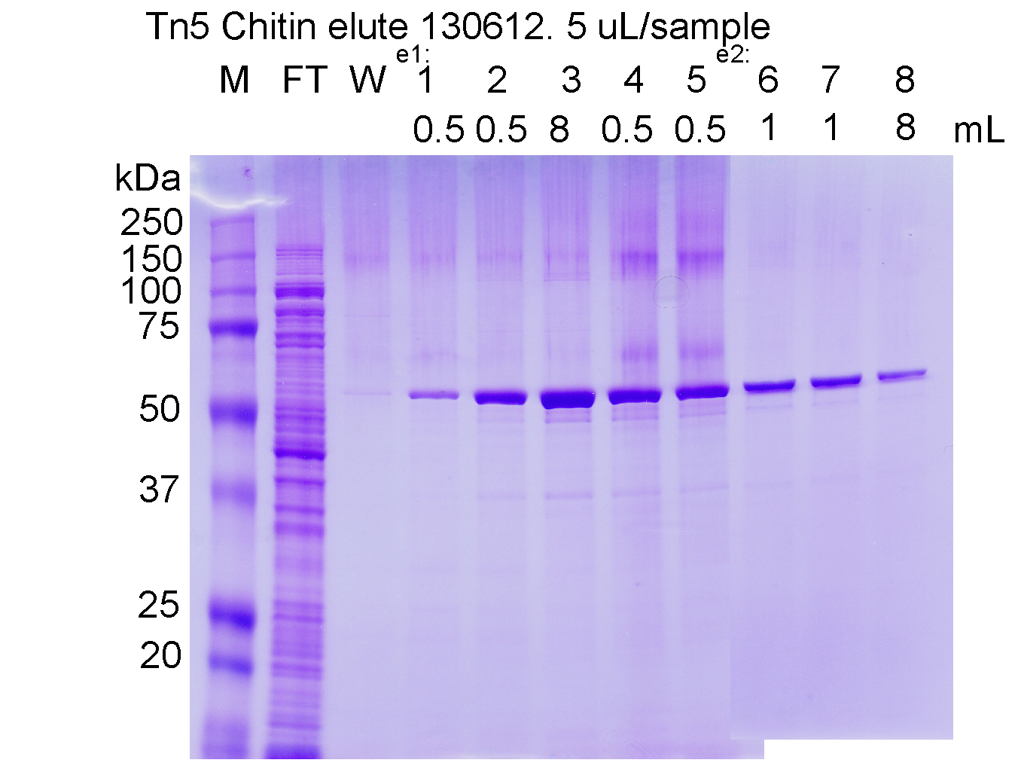

Care should be taken to elute the Tn5 as concentrated as possible. The first four-five fractions should be about five drops each, so that the start of elution peak can be determined. The subsequent fractions can be about 0.5 mL (20 drops). Add 0.5 μL of each fraction to 25 μL of Bio-Rad protein assay solution (diluted 1:5 from stock) and check the color. At this step, the high DTT concentration interfers with spectrophotometric measurements. Alternatively, analyze fractions on SDS gel.

This protocol can also be used to produce soluble Tn5 without bound oligos. If MEDS oligos are added to the soluble Tn5 after elution (see below), this leaves some unbound MEDS oligos in the preparation. This can be removed subsequently by clean-up of the Tn5 reactions on Zymo-columns or with XP-beads.

Dialysis:
Pool the fractions with highest concentration (about 5 mL) and dialyze vs. at least 4 changes of 0.5 L 2x Tn5 dialysis Bf @ 4C (100 mM Hepes, pH 7.5, 0.2M NaCl, 0.2mM EDTA, 2mM DTT, 0.2% TX100, 20% Glycerol). Use Spectra/Por™ 6 Pre-wetted Standard RC Dialysis Tubing, 50 kDa, 28 mm #132542. Leave at least for 12 h for each dialysis. After this step, the A280 and A260/280 can be measured vs. buffer control and molarity can be calculated based on the 280 reading.
To the pooled dialyzed fractions, add 0.6 vol. 99.5% Glycerol yielding a final 50% Glycerol, 1.25xTn5 dialysis buffer and 0,625x the concentration before glycerol addition. Add glycerol at RT to the cold dialysate. Use a 1 mL pipet tip with about 3 mm cut off at the end. Eject slowly. When addition is finished, flip tube gently to mix. Glycerol sticking at the bottom of the tube can be stirred up with a sterile 10 uL plastic bacteriologic loop. Aliquot and store at high concentration, as this stabilizes the Tn5 best. Do NOT store in a "frost-free" -20C freezer. Use one that builds up ice, but that is not opened frequently. For final use, adjust to 12,5 μM concentration in 50% Glycerol and 1X Tn5 dialysis buffer..

If assembly with MEDS oligonucleotides is done after the dialysis step (see below), then the dialyzed Tn5 can be used directly for assembly if the OD280 is above 4-4.5, if not, it can be concentrated as described below.

We see no loss of Tn5 in the large pore dialysis tubing. The length of tubing used should be boiled briefly in 50% EtOH with 10 mM EDTA and rinsed in dH2O before use. Note: DTT has a strong absorbtion at 280 and residual DTT above the 1-2 mM may confound the Tn5 concentration readings. Also DTT dialyzes out very slowly.

On-column oligo assembly yields highly active Tn5 if A260/280>1. If 0.7 or less, specific activity is low. Dialysis vs 2xTn5 dialysis buffer results in a 1.25x concentration because there is 20% glycerol in the dialysis buffer vs. 10% in the column fractions.

Sephadex/PEG 35K concentration of Chitin column fractions
Usually fractions do not need to be concentrated after elution from Chitin. However, fractions with slightly lower Tn5 concentrations (before and after the main peak) are also usable, but may need to be concentrated. If concentration is desired, it is better to do this before dialyzing into 2x Tn5 Dialysis buffer. The reason is that Tn5 is more stable in the high salt HEGX (0.8M NaCl). These fractions can be easily concentrated 4-5 fold before dialysis by sprinkling dry PEG35K around the dialysis bag and gently scraping off the caked, moist PEG after an hour or two, replacing with new PEG35K two or three times. Subsequently, the dialysis bag is left in the 2x Tn5 dialysis buffer O/N. This method is more gentle than the Amicon concentration (below).

Assembly of equimolar MEDS with Tn5 in solution:
A. Mix 0.25 vol. 50 μM MEDS A with 0.25 vol. 50 μM MEDS B in TE, 0.8 vol. 99.5% Glycerol, 0.5 vol. 50 μM Tn5 (A280 4.32 = 2.66 mg/ml) in 2XTn5 dialysis buffer (Final ≈12.5 μM each). Mix and keep 60 min at 37C. Store at -20C. After assembly with oligo in solution, OD measurements of Tn5 are confounded by the absorbance of residual free oligo.

If initial concentration of Tn5 is lower than 50 uM, compensate the volume difference by using more concentrated MEDS A/B oligos, in order to keep the final Tn5 at 12,5 uM.

Evaluation of oligo binding efficiency:

Solution assembly of previously frozen Tn5 with equimolar MEDS:
Unassembled Tn5 can be stored at -20 C or -70 C as a 55% glycerol stock, after addition of 1.1 vol 100% glycerol and 0.33 vol of 2x Tn5 dialysis buffer to the dialyzed Tn5 preparation from the Chitin column. Assuming a starting concentration of Tn5 at 3.0 OD280, this stock can be used later for Tn5 transposome assembly (below) by simply adding 0.143 vol. 100 μM MEDS A (1030) or MEDS B (1031) and proceeding as described above.

The assembly reaction gets cloudy at 37C, but clears on ice. This is because the CMC (critical micellar concentration) of Triton X-100 is exceeded at 37 C). Assembly at 37C is probably faster because it allows more breathing of the protein structure, thus higher probability of oligo binding. Glycerol can be lower or omitted in assembly reaction. If so, then add back glycerol after assembly.
Note: excessive concentration of the Tn5 in Amicon concentrators leads to some surface denaturation of Tn5, which lowers the specific activity.

Tn5 data:
(Tn5 = 53300 MW. Eμ = 86525. (A280: 8.65 = 5.33 mg/ml = 100 uM, A280: 1.000 = 0.616 mg/ml = 11.56 uM)

Molarities:
For molarity calculations, 1 ug of 1 kb = 1.52 pmoles.
1 cell = 10 pg total RNA (80-85% rRNA (28S,18S,5S), 15-20% small RNAs, 1% mRNA = 0.1 pg (0.03-2.5pg) = 0.05 attomole (up to 1.25 attomole) at 3Kb avg. length (Experimentally I get 0.1-1 pg/cell)

A-MEDS and B-MEDS oligos:
Tn5MErev : 5'-[phos]CTGTCTCTTATACACATCT-3'
(Tm = 52C/45,4C)
annealed to:
A. FC-121-1030: 5'-GTCTCGTGGGCTCGGAGATGTGTATAAGAGACAG-3'
(Tm = 104C/78)
B. FC-121-1031: 5'-TCGTCGGCAGCGTCAGATGTGTATAAGAGACAG-3'
(Tm = 96C/76,7C)

Illumina uses full length phosphorylated oligo as complement to the 1030 and 1031 oligos:
pMENTS1030: 5'-[phos]CTGTCTCTTATACACATCTCCGAGCCCACGAGAC-3'
pMENTS1031: 5'-[phos]CTGTCTCTTATACACATCTGACGCTGCCGACGA-3'
(Note: ME stands for Mixed End, which is not a relevant designation when using full length complements to the 1030 and 1031 oligos.)
If it is desired to add random nucleotides or indexes directly to the Tn5-bound oligos, this can be done between the 19 base (AGATGTGTATAAGAGACAG) Tn5-specific and the Illumina-specific parts of the MEDS oligos. (Tm are by the 2/4 rule and ThermoFisher calc.)

(Note: ME stands for “Mixed End”, which is not a very relevant designation when using full length complements to the 1030 and 1031 oligos.)

Transposase assay:
Mix on ice: 12 uL H2O, 2 uL 10x TAPS-MgCl2, 4 uL 40% PEG8000, 1 uL HMW DNA @ 50 μg/ml, 1 uL A/B-MEDS Tnp @12.5 μM. Incubate at 55 C 7 min. To ice.

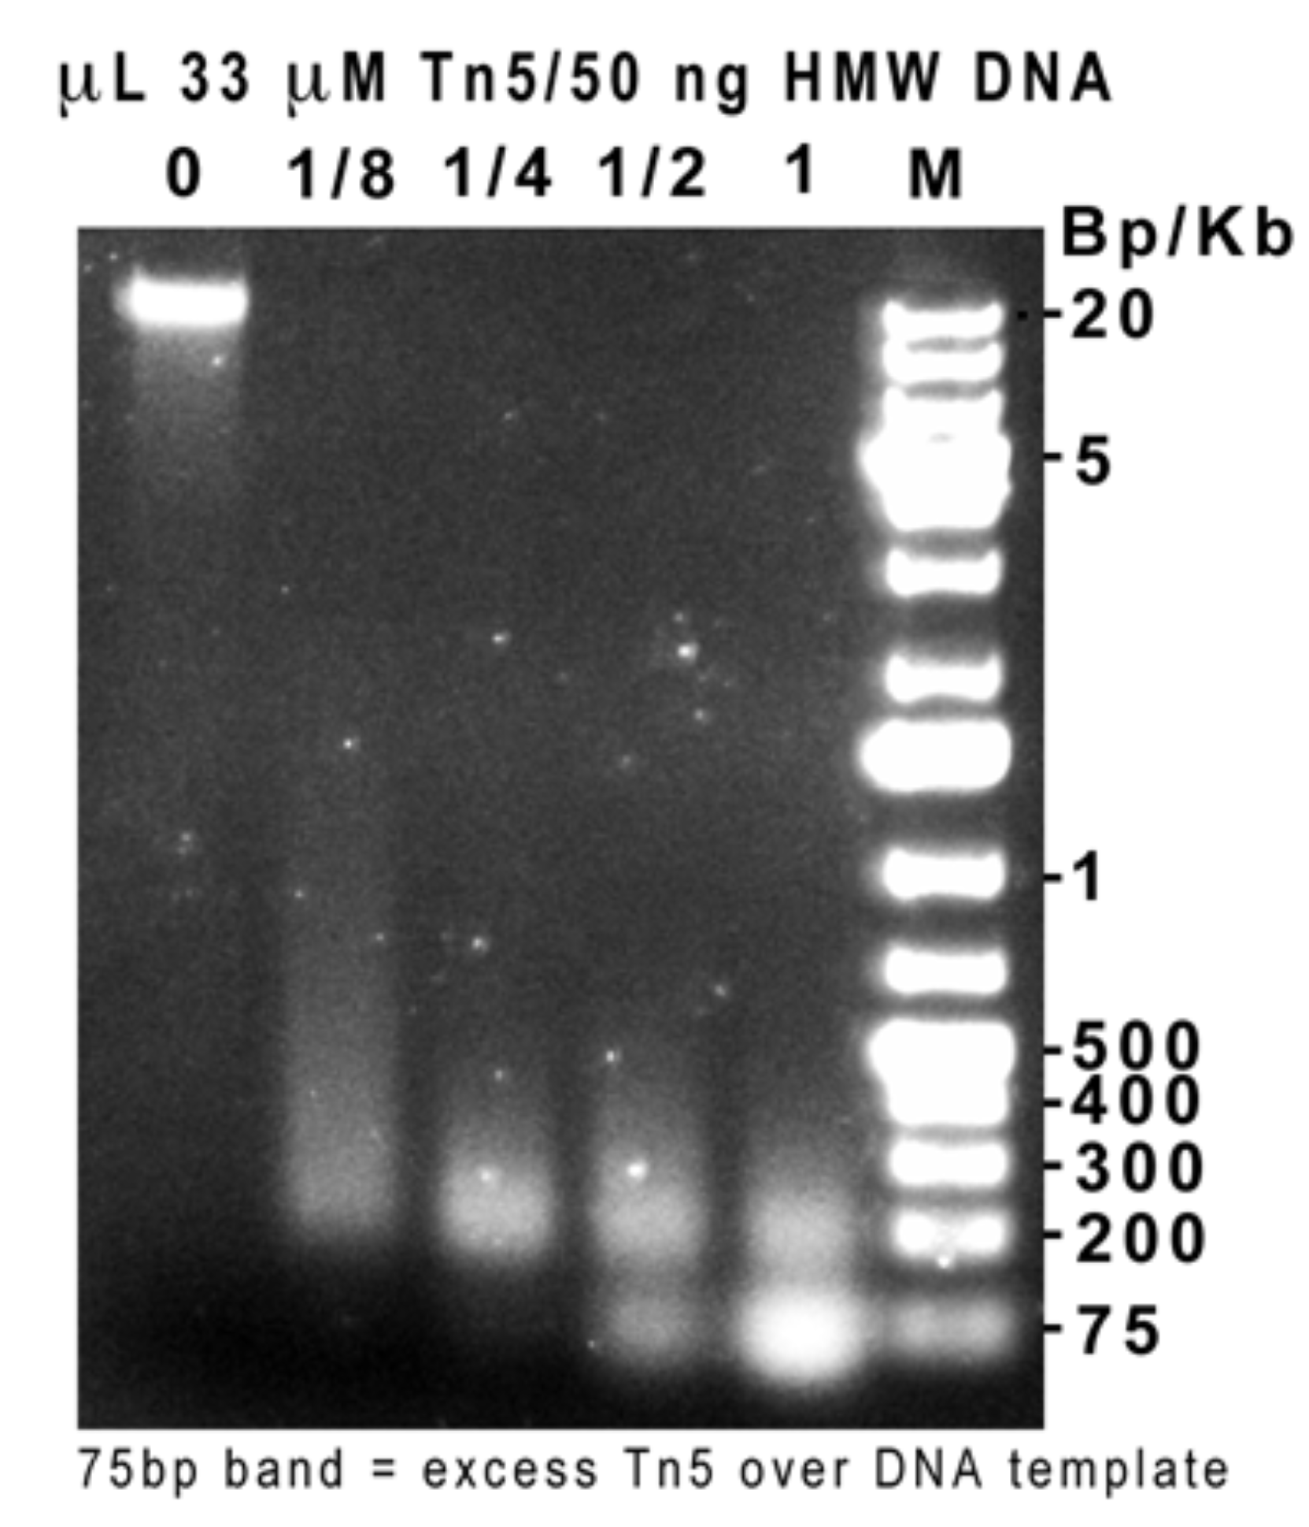

Work-up:
A. For use in subsequent PCR reaction in the library prep. protocol, Tn5 reaction can be stopped by adding 3 uL of 0.2% SDS to the 20 uL Tn5 reaction and heating again at 55C or RT for 7 min. In the subsequent PCR reactions, use up to 5 uL of this directly in final Illumina adapter PCR reaction.
B. For cleaning up Tn5 reactions, can also add 80 uL PB, add to Zymo Column, spin 1 min @13500, wash 500 uL PE, elute in 11 uL TE (or more if desired).
C. Can also use XP beads or Sera Mag SpeedBeads (45152105050350/250) prepared as below.

2-5 uL fresh 0.2% SDS tested. 3uL gave most consistent size of ≈1 kb for input of 1-4 ng input DNA.

PCR amplification for the test reactions:
Add 10 uL 2x DreamTaq + (Final) 200 nM primers. 10 pg can be amplified with 15-20 cycles. Initial step: 72C, 3 min.

PCR primers for Tn5 ends:

(Our Tn5: 1 uL for 50 ng - avg. 300bp, 2 uL - avg. 250 bp. More Tn5 gives no reduction of size NaCl depencence: At 50 ng input DNA, 100 mM NaCl gives 700 bp, 200 mM gives NoCut. Tn5 can be inactivated in >0.02% SDS, RT or 55C 5 min but is active at 0.01-0.02% SDS. We use (final) 0.04% SDS for inactivation. Subsequent PCR works with KAPA HiFi or KODXL in 0.01% SDS.

Ratio of Tn5 to DNA at low DNA input:
Recently Simone has observed that when preparing libraries with low DNA input (100 - 0. 1 pg), the use of less Tn5 gives a higher fraction of mappable reads. We do not yet understand this completely, but the work-around is to use more diluted Tn5, 1/100 for example). This leads to a reduction in non-mappable reads at inputs of 100 - 0.1 pg DNA.

Reaction Buffers:

1x Illumina Bf = pH 7.27 @RT, density=10% DMF

Standard Tris-Mg-DMF Buffers from Patents:
5X TMgCl: 50 mM Tris-HCl, pH 8.4 - 9.0, 25 mM MgCl2.
5X TMgCl-DMF: 50 mM Tris-HCl, pH 8.4 - 9.0, 25 mM MgCl2, 50% DMF.
(Tested pH from 8.0 - 9.0 in 0.2 unit steps, no difference in Tn5 activity.)

Our currently preferred TAPS-PEG8K buffers:
10XTAPS-MgCl2: 100 mM TAPS-NaOH (or KOH), pH 8.3 (RT), 50 mM MgCl2.
5XTAPS_PEG8K: 50 mM TAPS-NaOH (or KOH), pH 8.3 (RT), 25 mM MgCl2, 40% PEG8K

40% PEG 8000: 40 g PEG 8000 + 70 mL H2O. Warm to dissolve.

(This buffer works for input down to 1 pg with subsequent XP-bead purification, but no ethanol washes - elute and directly to 20-25x PCR.)

HEPES Buffer:
5X Hepes-MgCl: 50 mM Hepes-KOH, pH 7.2, 25 mM MgCl2.
Additions: 50% DMF or 40% PEG8K

(Hepes, pH 7.2 gives about 200 bp longer fragments than Tris or TAPS)

TAPS Buffers:
5XTAPS-DMF: 50 mM TAPS-NaOH, pH 8.3 (RT), 25 mM MgCl2 or MgOAc.
10x TAPS-KOAc: 100 mM TAPS-KOH, pH 8.3, 50 mM MgOAc, 500 mM KOAc.
5X TAPS-KOAc: 50 mM TAPS-KOH, pH 8.3, 25 mM MgOAc, 250 mM KOAc.
Additions for controlling fragment size:
4 uL 40% PEG8K, 2 uL 10x TAPS buffer for 20 uL final reaction vol:

Compared to TAPS-DMF buffer, we find that using TAPS buffer without DMF increases the average fragment size from 150-300 to 250-1.2 kb. Using the TAPS buffer with added KOAc we see the same effect, but the KOAc addition increases the fragment size somewhat compared to buffer lacking KOAc.
The TAPS-Mg-PEG8000 buffer can be used for all input DNA concentrations, but we find that the same 5x buffer with 50% DMF instead of 40% PEG8000 does not work well if the DNA input is less than 1 ng.

Can use 5-10uL Tn5 reaction without purification in a 25 uL KAPA HiFi or KOD XL amplification reaction, 20X ampl.

2xTn5 dialysis Bf: 1L (H20 added to vol.)
100 mM Hepes, pH 7.5 100 mL 1M or 23,83 g
200 mM NaCl 11.69 g NaCl
0.2 mM EDTA 400 uL 500 mM
2 mM DTT 2 mL 1M
0.2% Triton X-100 2 mL Triton X-100
20% Glycerol 252 g 100% Glycerol

Tn5 storage Bf: 100 mL: ( Mix + H2O, 42 mL)
50 mM Hepes, pH 7.5 5 mL 1M
100 mM NaCl 2 mL 5 M
0.1 mM EDTA 20 uL 500 mM
1 mM DTT 0.1 mL 1M
0.1% Triton X-100 1 mL 10%
50% Glycerol 63 g 100% Glycerol

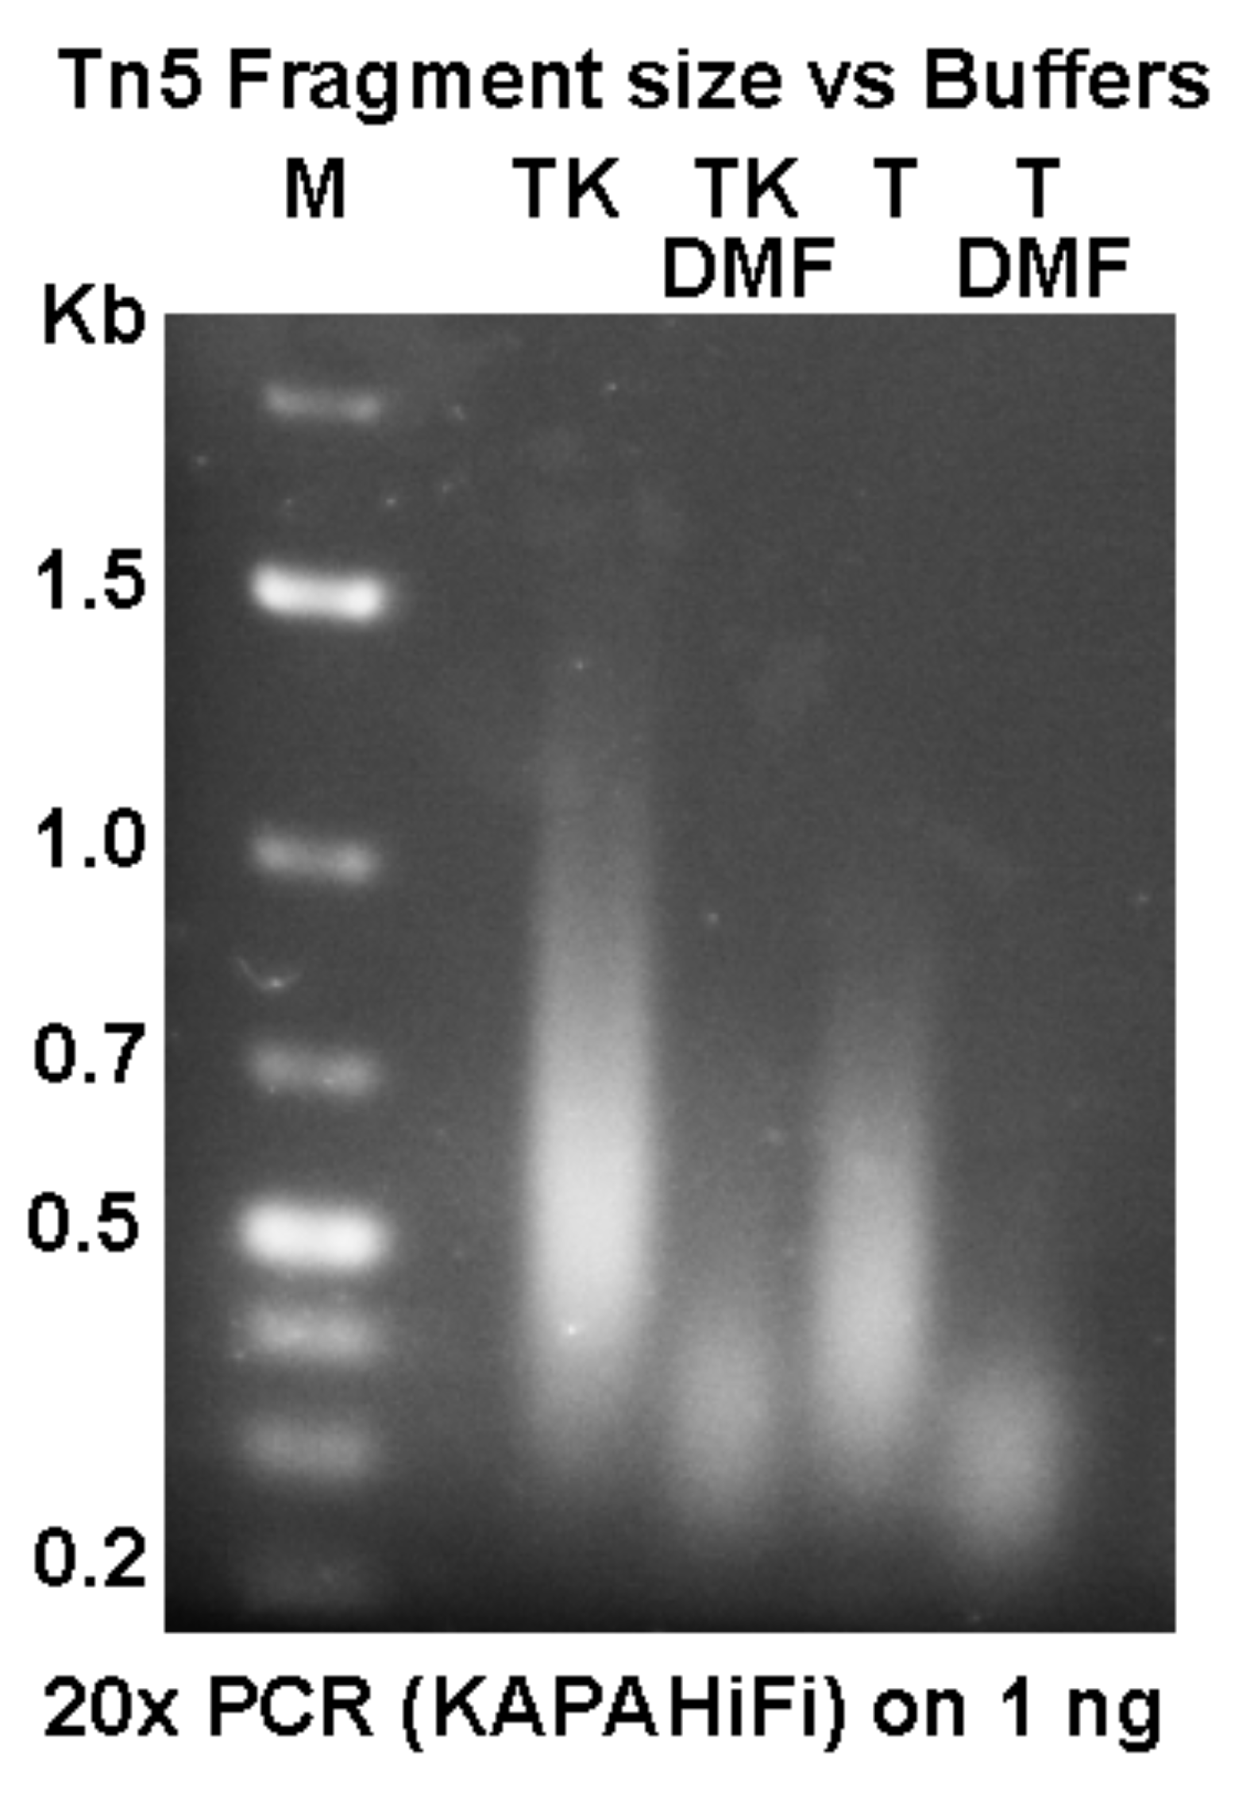

This assay shows TAPS and TAPS-KOAc buffers +/-DMF. We prefer TAPS because it drops less in pH at 55C than Tris. Similar results are obtained with TAPS/PEG8000 Bf. (see above).

Further protocol notes on Tn5 prep. from e-mail conversations:

I am sending you the latest protocol and a SDS gel where you can see how our elution profile looks like. The 100 kDa band might be T7 RNAPol, but we usually get this in the column wash, as you see on our gel. The new protocol has a SDS gel showing induced and uninduced cell lysates. You can see that the Tn5-Mxe-CBD fusion protein is about 75 kDa and the excised Tn5 about 55kDa. If your cleaved product is 50 kDa instead of 55, then you might have a short deletion at the N-terminal of the protein, in which case the translation start might be at the second ATG. This product is not active. As we have been primarily interested in the in-vitro use for sequencing, we have not worried about that second ATG. For in-vivo experiments, I would worry about having both those ATGs in the construct, as the product of the second ATG is Inh. The Inh is catalytically inactive but dimerizes with the active Tn5 and inactivates it in trans, which is its biologic function.

As I don't know how you have designed your in-vivo experiment I can't guess if our construct can be used or not, but if your idea is to transfect a transposome bound to a DNA loop containing your gene of interest, then that should work well with this construct. We have inserted GFP stably into tissue culture cells that way.

Since you picked up an inactive clone, I will briefly describe our procedures:
Transfect the Addgene plasmid into a RecA-negative host, like DH5alpha or Xl-1 Blue. Pick colonies and check the size of the XbaI -SpeI fragment. Grow up a few large scale preps of the ones that look right. Send these for sequencing from the T7 primer side. This will tell you if you have mutations/deletions in the N-terminal end of the fusion protein. Use this DNA to transform ER2566. Grow up 6 colonies in 5 mL O/N. Take 0,5 mL from each culture into each of two new 2 mL cultures. (the remaining 4 mL culture is kept at 4C) Grow for 1 hour, then add IPTG to one of the two and continue growing for 3-4 hours. Pellet the cells and resuspend pellet in 250 uL SDS sample buffer, Heat as usual and run a 10% (or gradient) gel, stain and look for the induced 75kDa band. If OK, inoculate the remaining 4 ml culture in 1L LB and grow to about 1 OD600 before adding IPTG. Shake for 4 hours, and proceed acc. to protocol. Transformed 2566 cells might loose expression after freezing, so testing from colonies needs to be done again, or just retransform with stock DNA and test.

Sera-Mag bead preparation (140319).
(Rohland, N., and Reich, D. Genome. Res. 2012, 22: 939-946)

Initially make one solution of 24% PEG and one of 20% PEG, as described below. Test by capturing 1 μg of 1 Kb+ Ladder from Fermentas (= 20 μL ladder (diluted 1:10) + 20 μL of PEG solution. Depending on the capture of the 200 and 300 bp fragments, adjust PEG concentration as described below, to achieve selective capture of fragments above desired size.

Initial PEG solutions:
Vt = 50 mL.
10 mL 5M NaCl (2.92 g)
500 μL 1M Tris-HCl, pH 8.0
100 μL 0.5 M EDTA.
12 g PEG 8000 or 10 g PEG 8000.
50 μL 10% Igepal CA630 (0.01 %)
250 μL 10% Sodium Azide (0.05%)
H2O to 49 mL

(1. If desired, can warm up to ≈ 40 C to speed up solubilization of PEG.
2. the Igepal is added to facilitate removal of PEG solution after addition of DNA sample. Igepal reduces surface tension We find that 0.01-0.02 % is suficient.
3.Optionally, Sodium Azide can be added to the SeraMag-PEG suspensions to improve shelf life. Use 0.05-0.1% Sodium Azide, i.e.250-500 μL of a 10% stock solution.)

SeraMag bead preparation:
Resuspend beads carefully (Thermo Sera-Mag Speed Beads #45152105050250, 15 mL of 5% suspension, 0.796 μM diameter).
Withdraw 1 mL of bead suspension into a 2 mL Eppendorf tube.
Mag., remove supernate. (The wet mag. pellet weighs about 0.217 g)
Add 1 mL 10 mM Tris-HCl, pH 8.0, 1 mM EDTA (TE), suspend beads off magnet.
Mag., remove supernate and resuspend again in TE.
Mag., remove supernate again and resuspend off (magnet) in 0.9 mL TE - final volume will be ≈ 1 mL).
Add to PEG solution above. resuspend beads.

Test
Mix 20 uL of 1Kb+ ladder with 20 μL of PEG solution. Keep 5 min, Mag. Remove supernate, wash beads (on magnet) with 2 x 80% EtOH, remove all EtOH, dry beads, redissolve DNA in 20 μL 1 mM Tris-HCl, pH 8.0 (if using Bioanalyzer to check size) in TE Buffer if analyzing on 1% Agarose gel.

If MW cut-off is too low with the 20% PEG solution, reduce by 0.5% as follows:
Remove 1.25 mL. Mag and remove the supernate. Add back 1.25 mL 1 M NaCl, 10 mM Tris-HCl, pH 8.0, 1 mM EDTA, 0.01% IgepalCA630. Resuspend beads and add back to main volume of PEG-SeraMag. Test cut-off again.

